Table of Contents
Right-click this table and choose "Update Field" → "Update entire table" to populate page numbers after opening this document in Word.
Document Control 3
Version History 3
Table of Contents 4
1. AI Platform Overview 5
Why it exists 5
What it delivers 5
Who can use it 5
2. Finding the Platform 6
3. The Complete Workflow 6
Step by step 7
4. Every Screen, Explained 8
4.1 Dashboard 8
4.2 Sessions 8
4.3 Recording screen (session detail) 9
4.4 Processing Queue 10
4.5 Transcript Center 10
4.6 Session results — Summary and Transcript tabs 11
4.7 Analytics 12
4.8 Settings 12
5. Recording a Session — Step by Step 12
6. Understanding Session & Processing Status 13
Session status 13
Processing stage (shown on the Processing Queue) 13
7. Troubleshooting 14
8. Frequently Asked Questions 14

ℹ NOTE
The figures in this guide are annotated screen-layout diagrams that reflect the actual structure of each screen — not photographic screenshots.

1. AI Platform Overview
The AI Intelligence Platform lets a trainer record a live classroom session from the browser and automatically receive, with no further manual work:
- A full transcript of the session, with speakers labelled and timestamps
- An executive summary of what was covered
- Key learning points, important questions raised, and action items

Why it exists
Session content — what was taught, what students asked, what was promised as a follow-up — previously existed only in a trainer's memory or informal notes. The AI Intelligence Platform turns every recorded session into a searchable, reviewable, permanent record, tied to the batch and programme it belongs to.

What it delivers
- Zero-effort capture — a trainer only starts and stops a recording; uploading, transcription, and summarization happen automatically in the background.
- Searchable transcripts — every session's spoken content becomes full text you can search.
- Structured takeaways — a coordinator can review a 60-minute class in under a minute using the executive summary and key points.
- Organization-wide visibility — dashboards and analytics show recording volume and processing activity across all sessions.
- Long sessions supported — classroom sessions up to 90 minutes are handled automatically, without any manual splitting or file-size management by the trainer.

Who can use it
Role | Can do
Founder | Full access — view, record, manage, and configure
System Administrator | Full access — view, record, manage, and configure
Operations Manager | View sessions, transcripts, and analytics
Programme Coordinator | View sessions, transcripts, and analytics
Trainer | View, create sessions, record, and retry their own sessions if processing fails
If your account doesn't have access, the AI Intelligence Platform section simply won't appear in your sidebar — contact your System Administrator.

2. Finding the Platform
Once signed in, look for AI Intelligence Platform in the left sidebar. It contains: Dashboard, Sessions, Processing Queue, Transcript Center, Analytics, and — for System Administrators and Founders only — Settings.

3. The Complete Workflow
This is exactly what happens, in order, from creating a session to reviewing the finished transcript and summary.
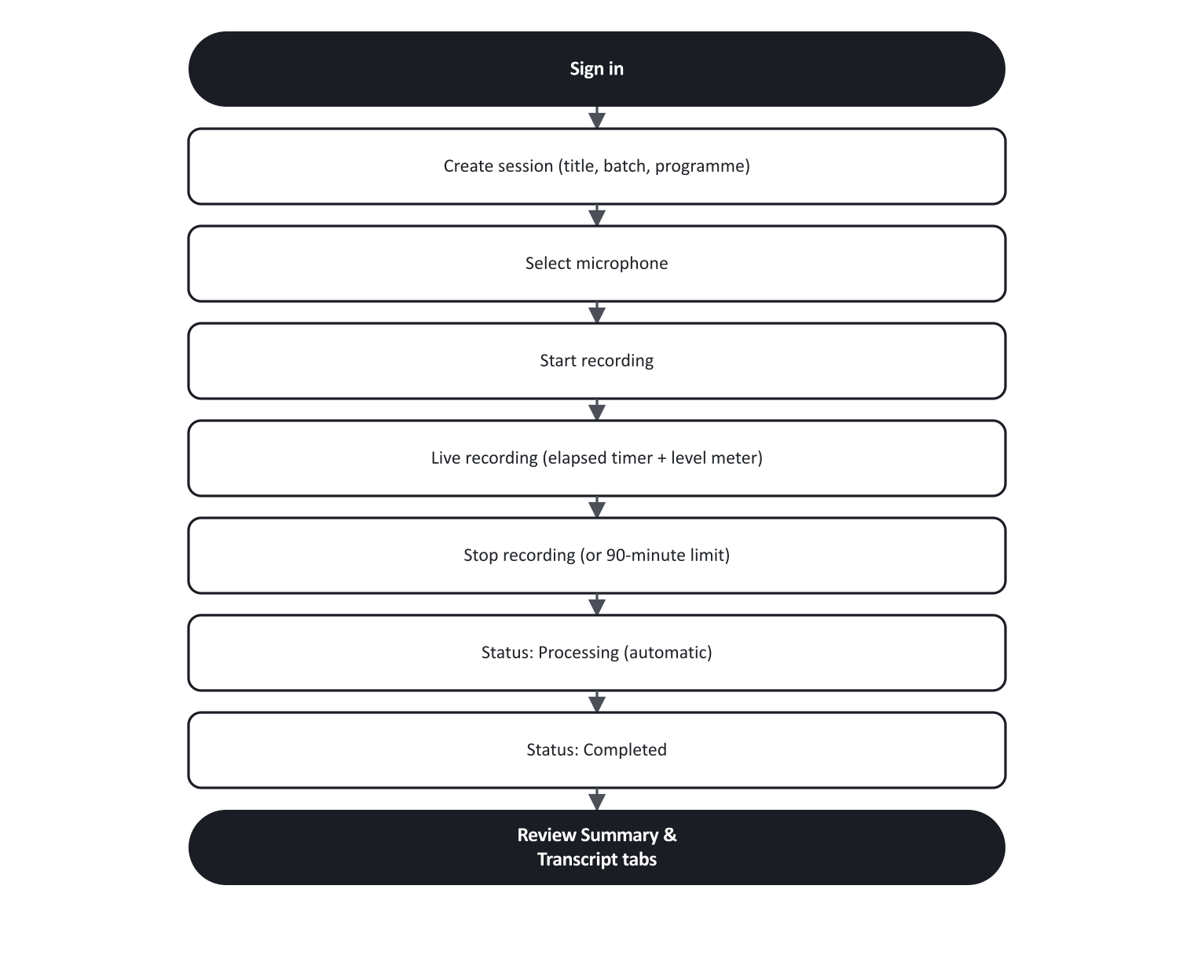
Figure 1. The complete trainer workflow, from sign-in to reviewing results.

Step by step
- Create a session. From Sessions, click Create session, give it a title, and optionally link a batch and/or programme. Submitting takes you straight to the recording screen.
- Select a microphone. Any connected audio device — a USB interface, a wireless lapel mic, a boundary conference mic, or a laptop's built-in mic — appears automatically in the microphone list, the same way it would in any other browser application. There's nothing to install.
- Start recording. Click Start recording. Your browser may ask for microphone permission the first time — allow it. The elapsed timer starts and the audio level bar should move when you or the room speaks.
- Record. Sessions can run for up to 90 minutes. There's no pause button — talk continuously until you're ready to stop.
- Stop recording. Click Stop recording. The button will briefly show Saving… while the last portion of the recording finishes uploading — stay on the page until it does.
- Automatic processing. The moment saving completes, the session status becomes Processing. You don't need to do anything else — the page (and the Processing Queue) will update on their own every few seconds.
- Review the results. Once status becomes Completed, open the session to see the Summary and Transcript tabs.
If a recording reaches the 90-minute mark, it stops itself automatically with an on-screen notice.

4. Every Screen, Explained

4.1 Dashboard
Purpose: at-a-glance activity and a shortcut into recent sessions.
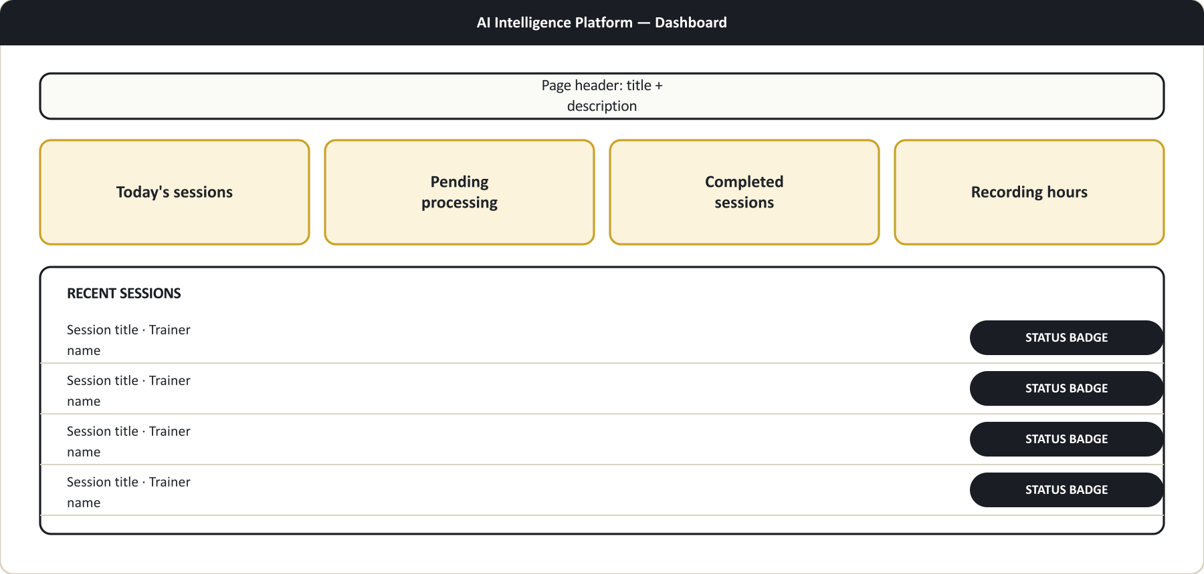
Figure 2. Dashboard layout (illustrative diagram, not a photographic screenshot).
The four tiles summarize today's activity at a glance. Below them, the eight most recent sessions are listed with a status badge each; clicking one opens its detail page. This screen updates itself automatically every few seconds, so you'll see new activity without reloading.

4.2 Sessions
Purpose: the master list of every session, and where you start a new recording.
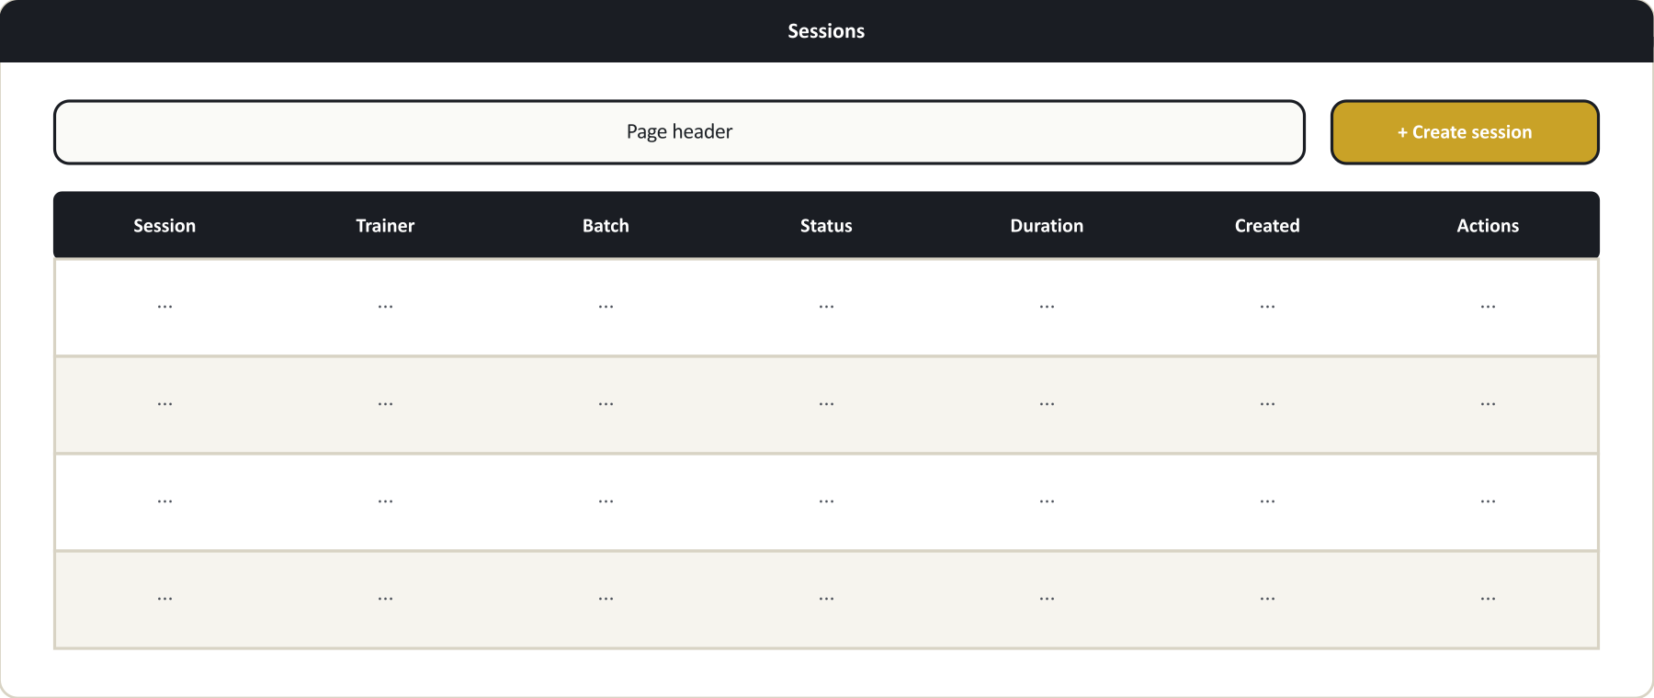
Figure 3. Sessions list layout (illustrative diagram, not a photographic screenshot).
If you can create sessions, a Create session button appears top-right. It opens a short form:
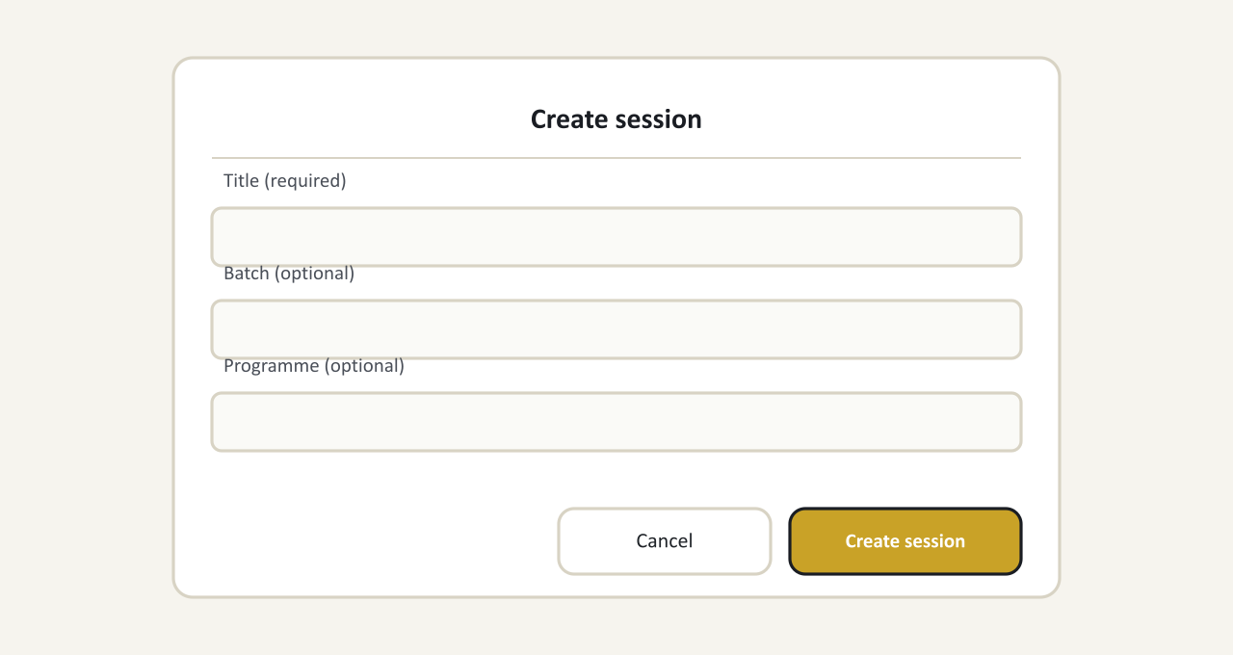
Figure 4. Create session dialog layout (illustrative diagram, not a photographic screenshot).
Submitting takes you directly to the recording screen. If you have permission to remove sessions, a delete action appears per row — removing a session hides it from this list; the recording and any transcript or summary already generated are kept, not permanently erased.

4.3 Recording screen (session detail)
Purpose: everything about one session — recording controls, live processing status, and final results, all in one place.
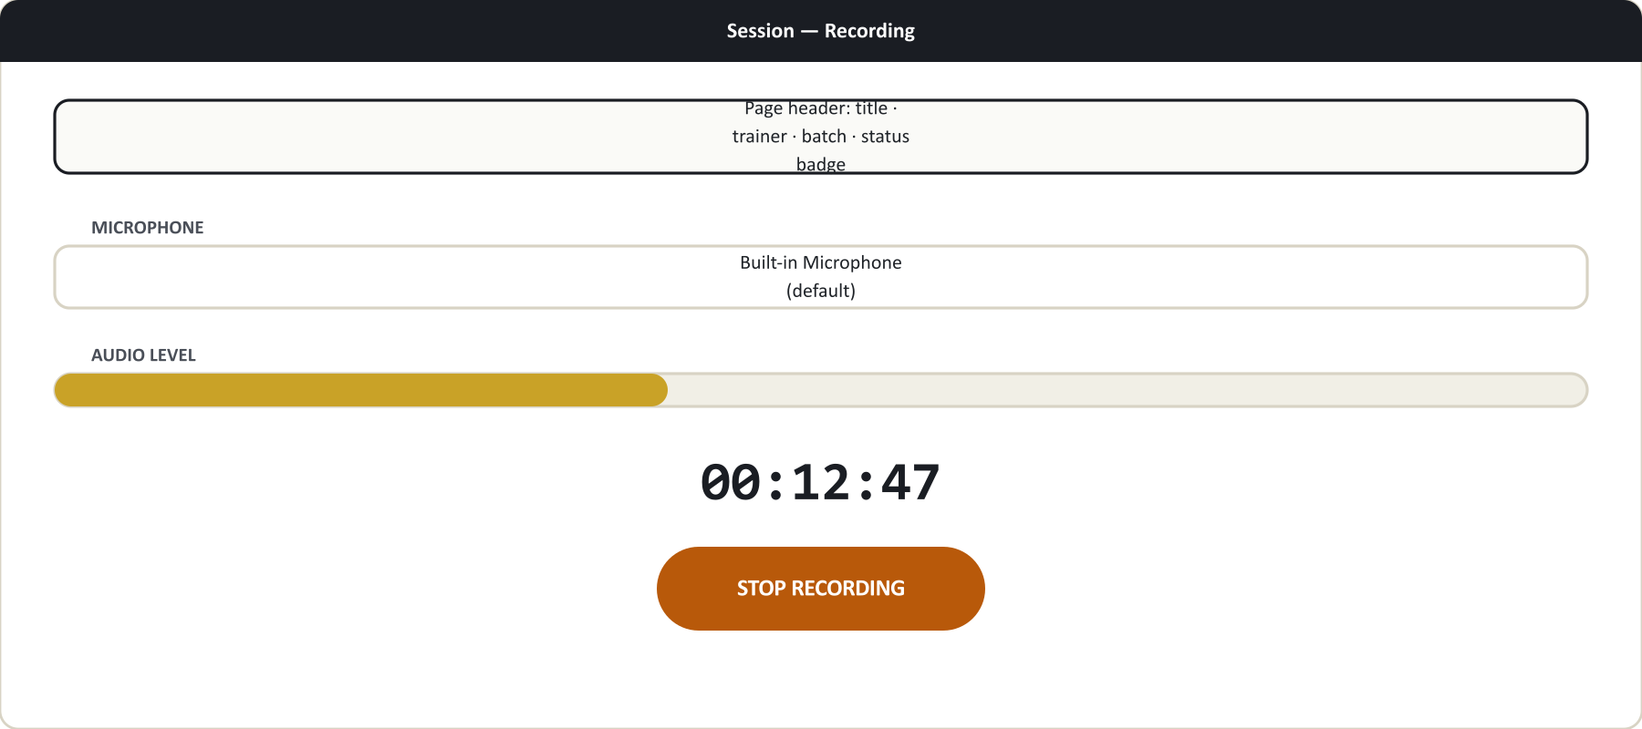
Figure 5. Recording screen layout (illustrative diagram, not a photographic screenshot).
- While the session is Draft, the recorder controls above are shown.
- While Processing, a notice explains that transcription and AI analysis are running automatically — the page refreshes itself, no action needed.
- Once Completed, the recorder is replaced by two tabs — see §4.6 below.

4.4 Processing Queue
Purpose: live visibility into every session currently being transcribed and analyzed.
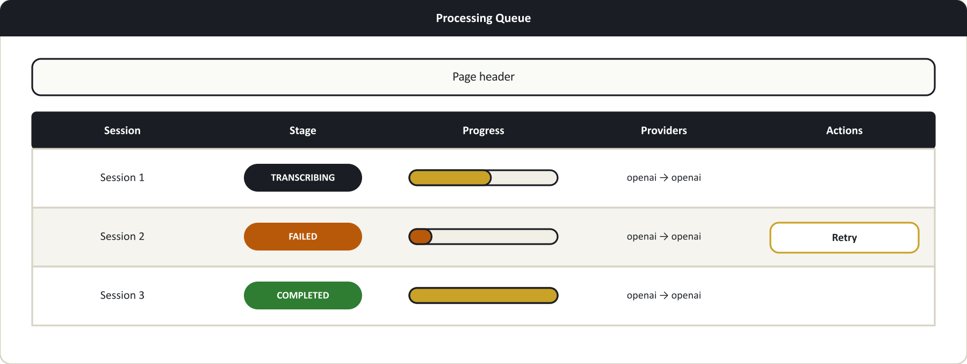
Figure 6. Processing Queue layout (illustrative diagram, not a photographic screenshot).
Each row shows which stage a session is at (see §6 for the full list) and a progress bar. If a job has failed, a Retry button appears for the trainer who owns it (and for System Administrators/Founders on any job) — clicking it picks up right where processing left off, rather than starting over.

4.5 Transcript Center
Purpose: a quick way to find and open any session that has a finished transcript.
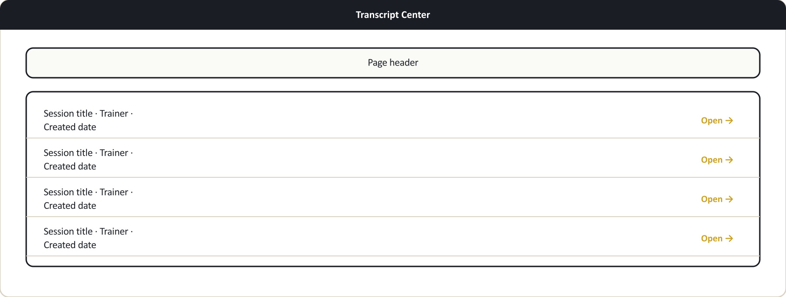
Figure 7. Transcript Center layout (illustrative diagram, not a photographic screenshot).
This page is a jump-list only — the transcript text itself is read on the individual session's Transcript tab (§4.6).

4.6 Session results — Summary and Transcript tabs
Once a session is Completed, its page shows two tabs:
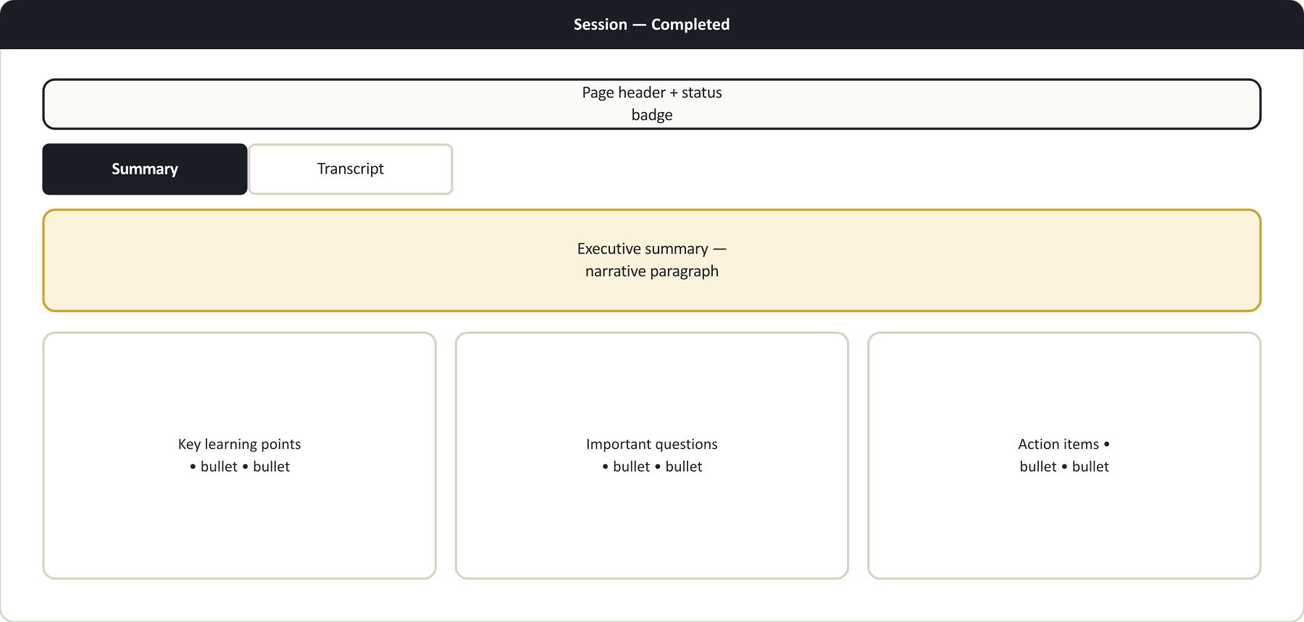
Figure 8. Completed session layout — Summary and Transcript tabs (illustrative diagram, not a photographic screenshot).
Summary tab — four cards:
- Executive summary — a narrative paragraph describing the session.
- Key learning points — the main takeaways.
- Important questions — questions raised during the session.
- Action items — follow-ups identified from the discussion.
If the AI didn't identify anything for a given list, it shows "None identified." rather than being left blank.
Transcript tab:
- A search box lets you find any word or phrase spoken in the session — type to filter, clear to see everything again.
- Each line shows a timestamp, a speaker label (Trainer, Student, or Unknown speaker), and the spoken text.
- Timestamps are for reference; there is no audio playback on this screen.

4.7 Analytics
Purpose: organization-wide activity over the last 30 days.
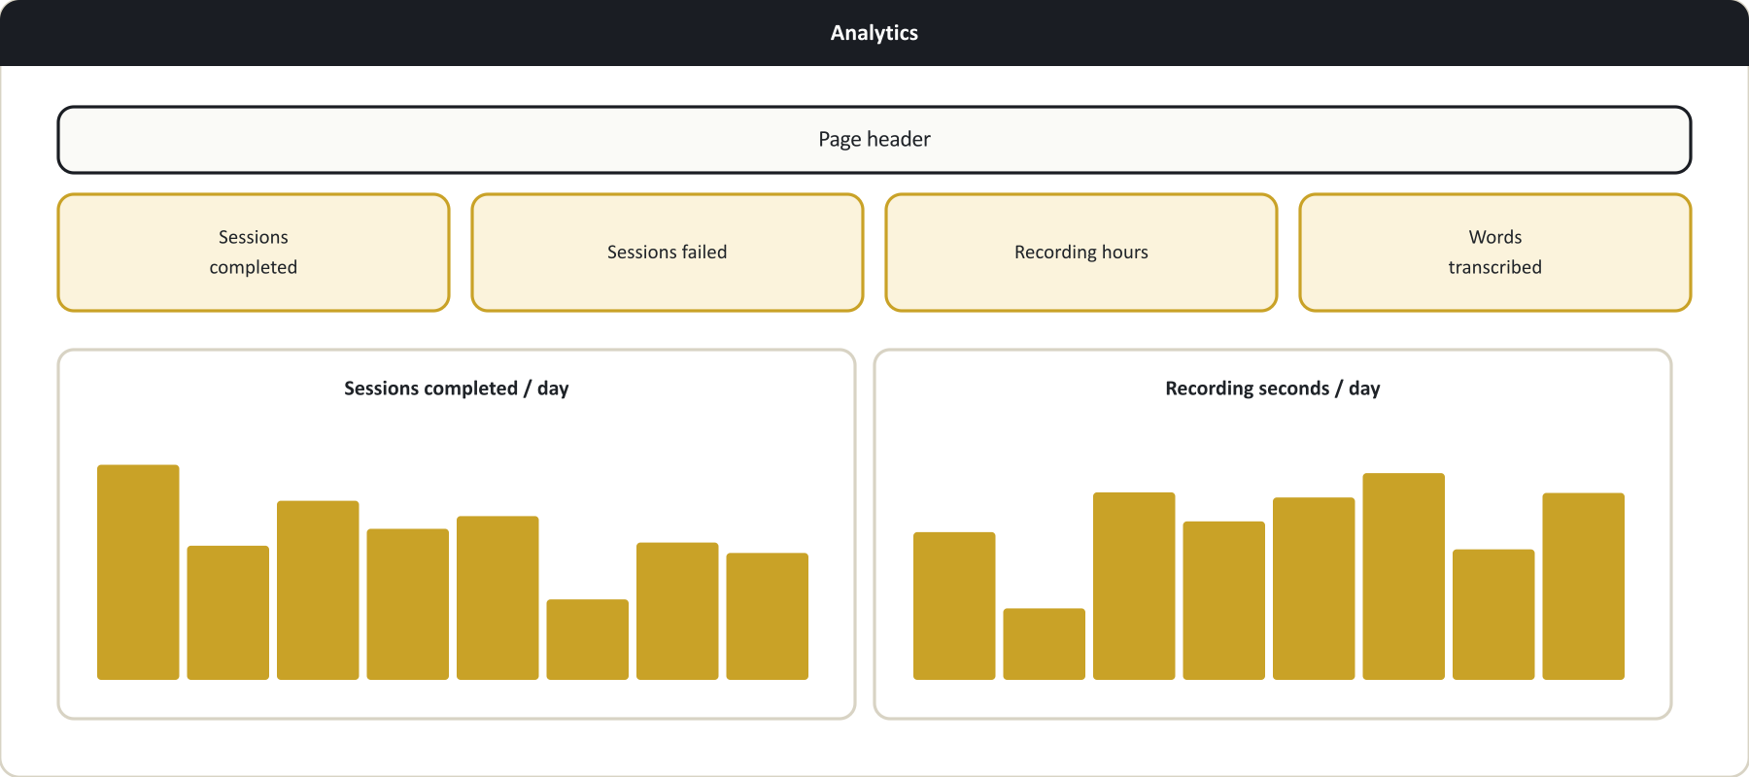
Figure 9. Analytics layout (illustrative diagram, not a photographic screenshot).
Four running totals plus two simple daily charts. Hover a bar to see its exact date and value.

4.8 Settings
Settings is available to System Administrators and Founders only — see the Administrator Guide.

5. Recording a Session — Step by Step
- Go to Sessions → Create session, enter a title, optionally choose a batch/programme, and submit.
- On the recording screen, confirm the correct microphone is selected in the dropdown.
- Click Start recording and accept the browser's microphone permission prompt if asked.
- Speak normally. Watch the audio level bar — it should move when there's sound in the room. If it stays flat, double-check the selected device.
- When the session is finished, click Stop recording and wait for Saving… to complete before navigating away.
- You're automatically taken to the processing view. From here, you can leave the page — processing continues in the background and the session will show as Completed once ready.

6. Understanding Session & Processing Status

Session status
Status | Meaning
Draft | Session created, recording hasn't started
Recording | Actively capturing audio
Processing | Recording finished; transcription and AI analysis running
Completed | Transcript and summary are ready to view
Failed | Processing hit an error — see the Processing Queue for detail

Processing stage (shown on the Processing Queue)
Stage | Meaning
Queued | Waiting to begin
Transcribing | Converting the recording to text, segment by segment
Merging transcript | Combining all segments into one session transcript
AI analysis | Generating the executive summary, key points, questions, and action items
Saving | Writing the final results
Completed | Finished
Failed | An error occurred — see the message shown on that row

7. Troubleshooting
What you're seeing | What it means | What to do
Microphone list is empty, or only shows "Microphone 1" | Your browser hasn't been granted microphone permission yet | Click Start recording to trigger the permission prompt, and allow it
Audio level bar never moves while recording | The wrong device is selected, the mic is muted, or a wireless device lost connection | Select the correct device before starting; check your device's mute switch
"Recording segment couldn't be saved — check your connection" | A short network interruption prevented part of the recording from uploading | Check your internet connection; if it keeps happening, try a more stable connection
A message asking you to contact support instead of re-recording | Part of the recording didn't finish saving when you clicked Stop | Do not delete the session or start over — contact a System Administrator; the portions that did save are safely stored
Browser tab was closed or the browser crashed mid-recording | The recording in progress cannot be resumed from where it left off | Start a new session; ask a System Administrator to check the interrupted one
A session has been on "Processing" for a while | Normal for longer recordings — each segment is transcribed in turn, not all at once | Check the Processing Queue for the current stage; only take action if the stage shows Failed
A processing job shows Failed | The AI transcription or analysis step hit an error (shown under the stage) | Click Retry if you own the session, or ask a System Administrator
No Retry button on a failed job | You don't own that session | Ask the trainer who recorded it, or a System Administrator
A page says you're not authorized | Your role doesn't have access to that screen | Ask a System Administrator to confirm your access
A completed session's summary/transcript looks generic or placeholder-like | AI processing isn't fully configured yet on your organization's account | Ask a System Administrator — see the Administrator Guide

8. Frequently Asked Questions
Can I pause a recording and resume it later? No. Recording runs continuously from Start to Stop. If you need a break, stop the session and start a new one.
What's the maximum length of a session? 90 minutes. The recorder stops itself automatically if you reach that limit.
Do I need any special recording hardware? No. Any microphone your computer recognizes — built-in, USB, wireless lapel, or a conference-room boundary mic — works automatically. The platform uses the same audio input list as any other application on your computer.
Can I see other trainers' sessions? If your role has view access to the AI Intelligence Platform, you can see all sessions across the organization, not only your own. This is a shared, organization-wide record.
Can I edit the transcript or summary? Not from this screen today. If something looks wrong, contact a System Administrator.
What happens if I delete a session? It disappears from the Sessions list, but the recording, transcript, and summary already generated are kept — it isn't permanently erased.
Why does the search box on the Transcript tab only search text, not speakers? The current search searches spoken text only. There's no separate "filter by speaker" control on this screen today.
How long is my session's audio kept? Your organization's System Administrator sets a retention policy in Settings — check with them for your organization's current practice.
Will I get notified when my session finishes processing? Check with your System Administrator about whether notifications are enabled for your organization.

